Date: Saturday, March 2
Sign up Deadline: February 16

Time: 9:00 – 12:00
Location: Reedsville Elementary School (350 Park Street, Reedsville)
Cost: $5.00 per member. Includes all 3 sessions. Money will be collected day of the event.
Sign up Form: https://forms.gle/E9qZby6pdkMrvUt17
Sessions: Each session will be 1 hour long and members will pick one activity per session. Youth can sign up for one session, two sessions, or all three sessions. Cost will be the same whether the youth choose one or three sessions.
Session 1 – 9:00 – 10:00 AM
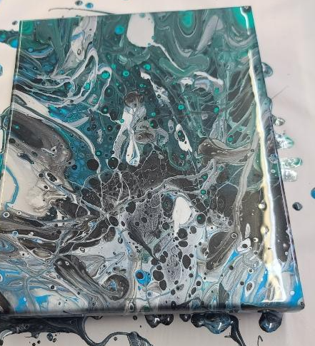
Cookie Decorating – Members will make frosting and learn different techniques on how to frost a cookie. Grades K-up
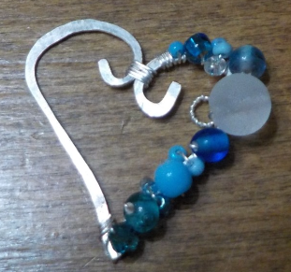
Pour Painting – Pour painting is a fun art technique that involves mixing acrylic paint with a thinning medium and pouring it on a canvas. The canvas is then tilted to allow the paint to flow, mix, and create unique designs. Grades 3 – up.
Wire Wrapped Heart Pendant– The pendant will be made from pre-cut wire pieces to the finished product. Participants will get to shape, hammer and wrap their pendant with beads. Grades 3 – up.
Session 2 – 10:00 – 11:00 AM
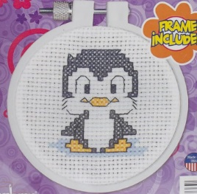
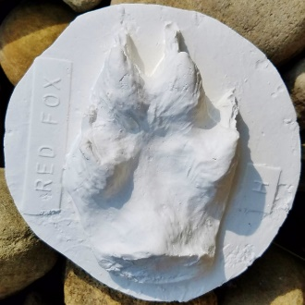
"Who's Been In My Backyard?"– Learn how to identify animals from their tracks and make a plaster cast of an animal track to take home. Grades K – up.
Bracelet Making – Members will learn how to make friendship bracelets and/or paracord bracelets. Grades K – up.
Beginner Cross stitch - Learn how to cross stitch and backstitch while making a small counted cross stitch. Grades 3 – up.
OVER

Session 3 – 11:00 – 12:00 PM
It’s nothin’ to make a Muffin! - Learn techniques on making quick breads. Create muffins using the muffin method. Choose the ingredients to make your own personalized muffin! Grades K – up.
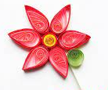
Quilling Flowers – Members will be making flowers out of paper that is coiled, which is called quilling. Grades 3 – up.

