Sheboygan County 4-H Cat Project
Celebrates the 29th Annual
Open Household Pet Cat Show!
A show for all people who love their household pet cats!
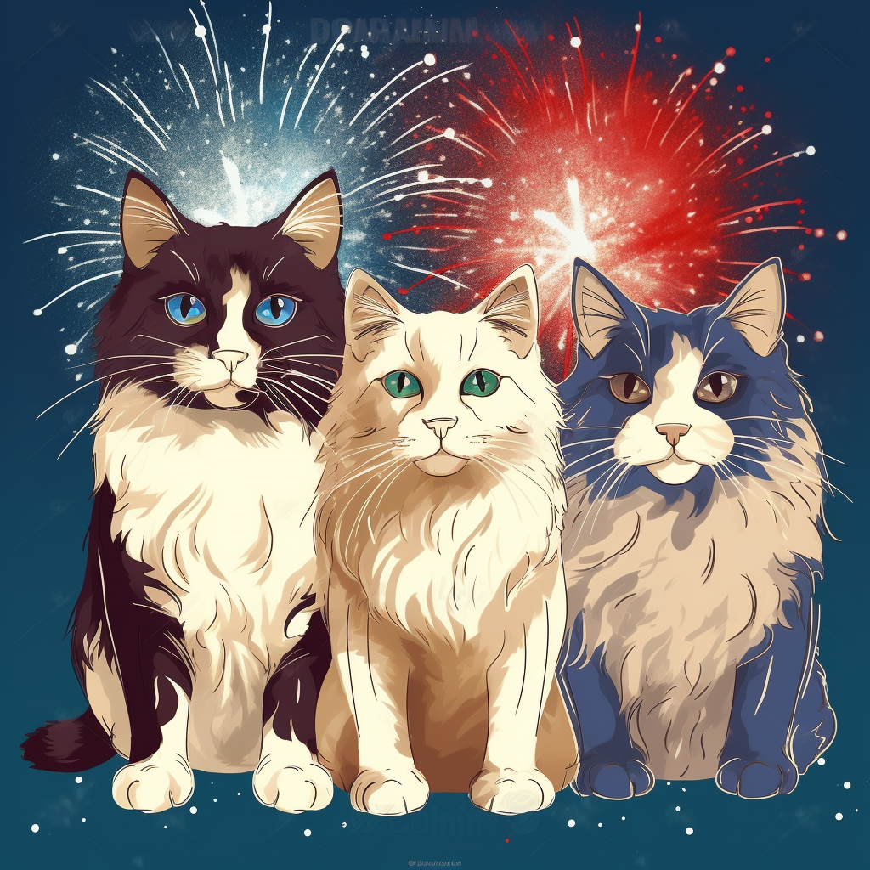
“The Wonderful World of Cats”
Sunday April 28, 2024
9:00am – 3:00pm
Sheboygan Lakers Ice Center
1202 South Wildwood Avenue Sheboygan WI 53081

- 3 Rings of judging - 2 Specialty Rings, 1 All breed
- Admission - $2 ages 6 and up OR Cat food donation:
3 cans or 1 bag / person (to be given to local shelter)

*Vendors *Silent Auction *Decorated Cage Contest
* Raffles *Food Available *Cat Costume Contest
* Spectator's Choice Award*

Adults and children ages 8 and older are welcome to enter.
Exhibitors do NOT have to be a 4H Member.

Entry closing date is April 13, 2024 or when cage space limit has been met.

Show Manager/ Entry Clerk: Jennifer Potter
email contact: sheboygan4hcatproject@gmail.com

“The Wonderful World of Cats”
The Wonderful World of Cats will be the theme of this year’s show. Feel free to pick any form of Disney-like theme to decorate your cages. There will also be a costume contest so dress your cat or you and your cat. Be creative!

SHOW HALL – Sheboygan Lakers Ice Center (Blue Line), 1202 South Wildwood Avenue, Sheboygan, WI 53081. FREE Parking.

CHECK-IN and HOURS - PLEASE NOTE TIMES!!!! Check in is from 7:30am to 8:30am on Sunday, with the show starting promptly at 9:00am. Advertised show hours are from 9:00am to 3:00pm. No exhibitors will be allowed to leave early without permission from show management. Please understand this, as spectators are paying to see your cats/kittens, not an empty show hall.

JUDGING (Three Rings) - Two judges will judge Specialty, meaning longhairs against longhairs, shorthairs against shorthairs and kittens against kittens. One judge will judge All breeds, meaning each cat against all others, regardless of coat length/age. Each entry that is judged will receive a participation ribbon. Each cat that finals will receive a Rosette. Any exceptional awards will be given at the close of the day.

SHOW RULES - This show is for cats and kittens 4 months and older. Your cat should be brought to the show in a carrier. Do NOT touch anyone's cat without their permission. Do NOT speak to or distract the judge during the judging process unless they ask you a question first. Keep the noise levels down and make sure walkways are clear. Cats should only be out of their cages while being judged or groomed right in front of your cage area. Do NOT walk around with them on leashes or in strollers at other times. Treat all visitors, co-exhibitors, vendors and judges politely.

HEALTH - This is a VETTED Show. If your cat/kitten does not pass vet-in, you cannot show them, and we cannot refund your fees. Any cat/kitten suspected of showing evidence for fungus, ear mites, fleas, or a contagious disease will not pass vet-in and must be removed from the show hall. All cats/kittens MUST be up-to-date on all immunizations (Distemper Combo and Rabies). A copy of the certificate of vaccination and rabies certificate must be included with entry & payment. All cats over 8 months old are adults and must be spayed or neutered.
PREGNANT CATS CANNOT BE SHOWN! NO cats are to be sold/adopted at this show. All cats must have their nails clipped unless declawed.

SUPPLIES - You must provide cat food, water, litter and a litter box for inside the cage.
You must also bring suitable material to cover the back, sides, top and floor of the cage.

CAT COLOR & COAT PATTERN - If you are unsure of your cat’s color or pattern, send a photo with your entry or email a photo to the 4-H Cat Project at sheboygan4hcatproject@gmail.com

CAGES & BENCHING – Cats/kittens will be housed in benching cages provided during the show. The cages are designed for 2 individual cat spots and cage space measures 22”x22”x22” for a single spot, or 22”x22”x45” for a double spot. The cages have wire dividers to separate cats/kittens if needed. SINGLE-CAT ENTRIES WILL BE ASSIGNED A HALF CAGE UNLESS A WHOLE CAGE IS REQUESTED AND THE ADDITIONAL HALF CAGE FEE IS PAID. (See entry/payment page.) If you choose to bring your own cage, it must not exceed the measurements of the provided cages. Pet carriers are not considered cages and cannot be used as such during the show to house your cat. Benching requests MUST be clearly indicated on the Entry Form and will be granted IF ABLE. We cannot guarantee your benching request but will do our best to accommodate.

**Changing benching without permission of show management will not be allowed. No cats/kittens may be kept or displayed in kennels or carriers under the benching cages.**

PAYMENTS - The club accepts checks & money orders made payable to:
Sheboygan County 4-H Cat Project. (Sheb. Cty. 4H Cat Proj.)
Mail entry payments, entries, and proof of vaccination to:
Jennifer Potter, 2625 S. 8th St., Sheboygan, WI 53081

*Limited financial assistance may be available for entry fees.
To apply please contact us at sheboygan4hcatproject@gmail.com

VENDORS - Crafters of cat/pet-oriented and/or unique materials welcome! Home-based small businesses are also welcome. Keep in mind this is a pet-oriented event when considering your potential sales. Please reach out to Alice Samse @ 920-467-1558 or email: amsamse@charter.net Deadline: Application/fee deadline is Mon. April 22, 2024 or until the vendor area is full.

DONATIONS - We also need silent auction and raffle items. Auction items are baskets of products or larger items of higher value. Raffle items can be smaller, less valuable items. We may combine smaller products together from multiple sources to create larger, themed auction items. If you are able to contribute in this manner, please indicate below. Contact Sarah Samse (text only) at 920-889-8739 or phone Alice Samse at 920-467-1558 to arrange a pickup of your item (s) NO LATER than April 20, 2024.

SPONSORSHIPS - This show is our sole source of income for the year. Without the support of individuals and groups who have so generously sponsored our program, this show could not exist. We greatly appreciate all who have contributed to help us succeed! No amount is too small, even $10, $15 or $20 would help with costs such as hall rental fee, postage, advertising, and supplies. All financial contributors will be acknowledged at the show. Please fill out the level of sponsorship on your entry form.

IN HONOR OF (living) /IN MEMORY OF (deceased) - Donations of any amount can be made to honor or remember a person or pet of any kind. Names will be displayed on a memory board. If you would like to include a 4x6 (non returnable) photo of person or pet for the sign, please include it with your entry form.

FOOD- Will be available for purchase from the Blue Line Lakers Ice Center. No outside food sales allowed in the show hall.

SHEBOYGAN COUNTY 4-H CAT PROJECT
29th ANNUAL HOUSEHOLD PET OPEN CAT SHOW
“The Wonderful World of Cats”
Sunday, April 28, 2024
Sheboygan Lakers Ice Center
1202 South Wildwood Avenue, Sheboygan WI 53081
Check-in & Vet-in: 7:30 - 8:30 a.m. Show starts at 9:00 a.m. SHARP!!!
Entry Deadline: April 13, 2024

Exhibitor Name: _________________________________________
Address: ______________________________________________
City: ________________________ County: ___________________ State: ___ZIP:______ Phone: ________________________ Email: ___________________________________

Are you at least 8 years of age? Yes / No
Are you bringing your own cage? Yes / No
Are you currently in 4-H? Yes / No - If Yes, What County? ________________
Do you have a benching request? * Yes / No - If Yes, Specify: _____________________ ______________________________________________________________________________ *We cannot guarantee your benching request, but will do our best to accommodate.

Fee Summary:
Cats/kittens will be housed in benching cages provided during the show. The cages are designed for 2 individual cat spots and cage space measures 22”x22”x22” for a single spot, or 22”x22”x45” for a double spot. The cages have wire dividers to separate cats/kittens if needed. SINGLE-CAT ENTRIES WILL BE ASSIGNED A HALF CAGE UNLESS A WHOLE CAGE IS REQUESTED AND THE ADDITIONAL HALF CAGE FEE IS PAID.

1st Cat 2nd Cat 3rd Cat & up Extra Half-Cage
$15.00 $12.00 $10.00 $10.00

1st Cat Qty at $15 = __1__
2nd Cat Qty at $12 = _____
3rd Cat and up Qty at $10 = _____
Extra Half-Cage Qty at $10 = _____

Gold Sponsor Donation $100 and up = _____

Silver Sponsor Donation $50-$99 = _____

Bronze Sponsor Donation $1-$49 = _____

In Honor/ In Memory of donation: __________________ $_____ = _____

GRAND TOTAL $_______
Please make checks payable to: Sheboygan County 4-H Cat Project
Cat Entry Information:

Exhibitor’s Name: ____________________________
Cat’s Name: _________________________________________ Date of Birth: _______
Sex/Alteration: (circle one) Male-Neutered Female-Spayed Male-Kitten Female-Kitten
Coat Length: (circle one) Shorthair Longhair
Coat Color: __________________________________Coat Pattern: ________________
Eye Color: ________
Is this your cat’s first show? Yes / No
Handicaps or special needs? ______________________________________
Rabies vaccination- Next due date________________
Distemper Combo vaccination- Next due date______________

Exhibitor’s Name: ____________________________
Cat’s Name: _________________________________________Date of Birth: _______
Sex/Alteration: (circle one) Male-Neutered Female-Spayed Male-Kitten Female-Kitten
Coat Length: (circle one) Shorthair Longhair
Coat Color: __________________________________Coat Pattern: ________________
Eye Color: ________
Is this your cat’s first show? Yes / No
Handicaps or special needs? ______________________________________
Rabies vaccination- Next due date________________
Distemper Combo vaccination- Next due date______________

Exhibitor’s Name: ____________________________
Cat’s Name: _________________________________________ Date of Birth: _______
Sex/Alteration: (circle one) Male-Neutered Female-Spayed Male-Kitten Female-Kitten
Coat Length: (circle one) Shorthair Longhair
Coat Color: __________________________________Coat Pattern: ________________
Eye Color: ________
Is this your cat’s first show? Yes / No
Handicaps or special needs? ______________________________________
Rabies vaccination- Next due date________________
Distemper Combo vaccination- Next due date______________

********A copy of the current shot records including Distemper Combo and Rabies
MUST accompany this form. ********

Entry Deadline April 13, 2024

Mail entry form, payment and vaccination proof to:
Jennifer Potter
2625 S. 8th St.
Sheboygan, WI 53081

